Phase 2: Requirement Analysis Document
Project Title: Import Data using Transform maps (Spreadsheets).

1. Source Data Specification
- Format: Microsoft Excel (.xlsx)
- Fields: Employee ID, Employee Name, Email, Department, Location

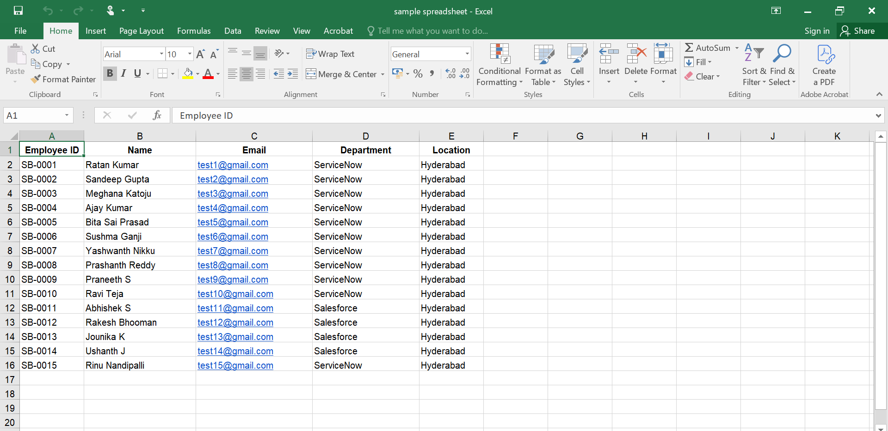

2. System Requirements & Field Schema
- Target Table: u_employee_test

Field Mapping Specification
- Employee ID: String -> u_employee_id
- Employee Name: String -> u_employee_name
- Email: String -> u_email
- Department: String -> u_department
- Location: String -> u_location
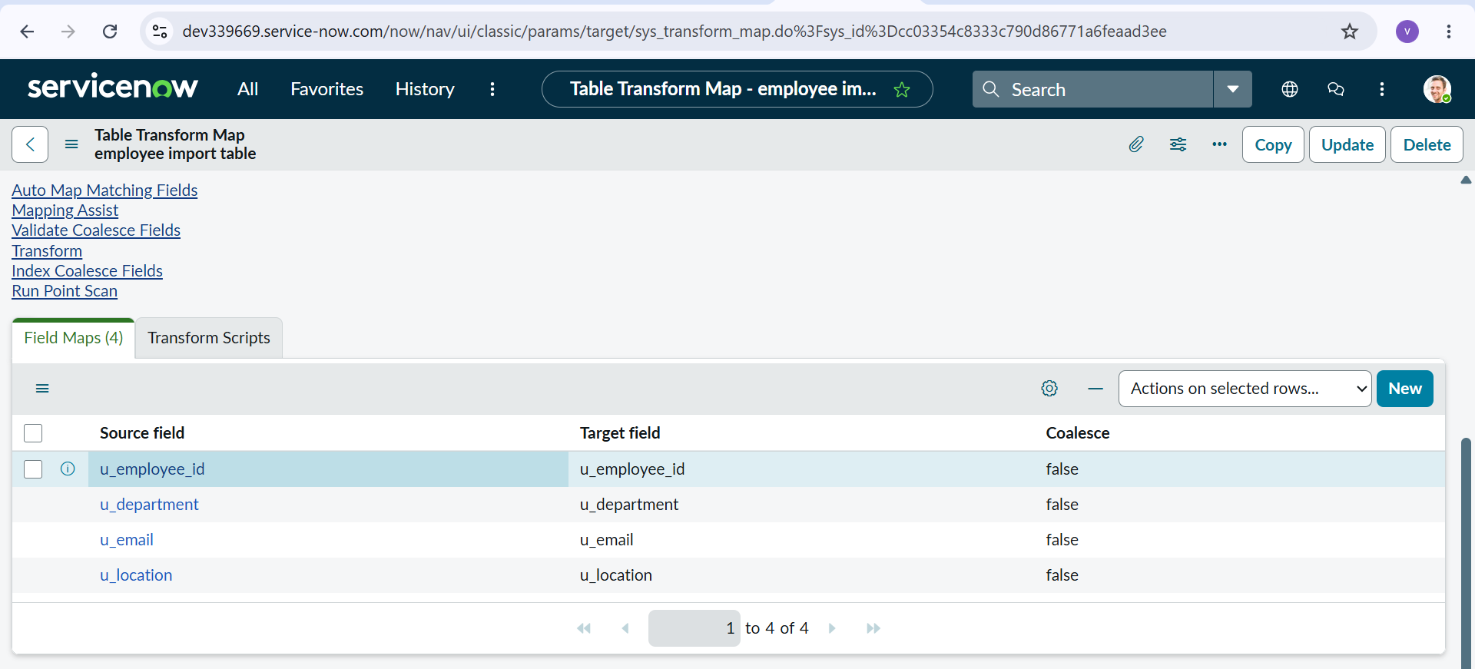

3. Checklist
Image 1: Excel Spreadsheet Dataset

- Image 2: ServiceNow Load Data Module Setup

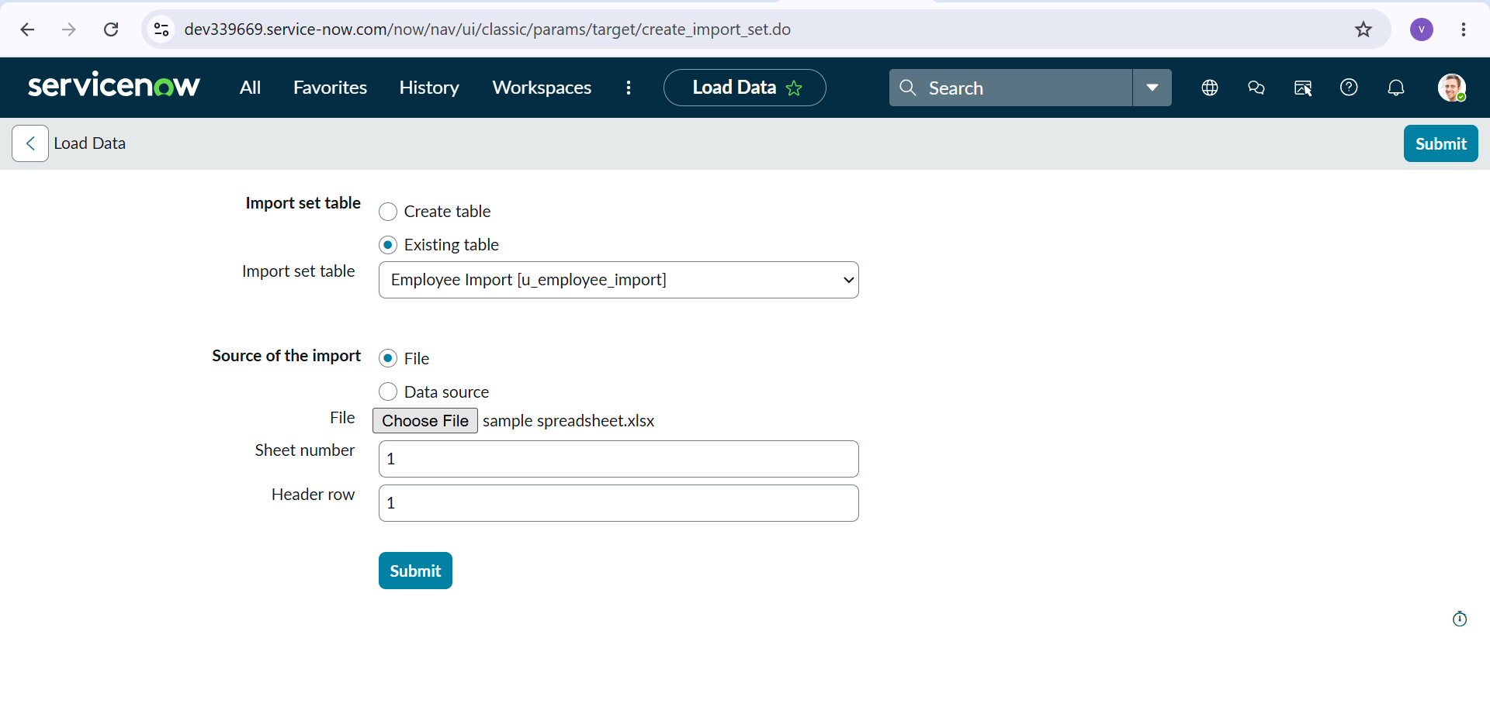

- Image 3: Employee Import Staging Table ConfigurationStaging Table: u_employee_import

